**TASKs**

**For multiple assets:**

First, we RANDOMLY choose ten assets as a portfolio, put them into our training model, and

INPUT: ten assets’ return

TASK:

1. Predict them separately,(Predict one every time) get ten predict results,calculate average as the result of this pool, choose the TOP 10 porfolio.
2. Calculate the average return of these ten assets, and then predict for the next month, choose the TOP10 pool.

OUTPUT: Ten asset pools.

**For portfolio:**

INPUT1: assets’ return

TASK1: Ask the weight of each assets.

We predict each assets’ return for the next month, then we rank and choose TOP10 assets as the portfolio and calculate their weights.

OUTPUT1: weight of each asset in portfolio.

INPUT2: assets’ return

TASK2: Ask the weight of each portfolio

We RNDOMLY choose ten assets as the portfolio, predict the return of this portfolio and choose TOP10 portfolio,calculate their weights.

OUTPUT2: weight of each portfolio.

**Questions:**

**Q1:**If we want the weight of each assets,then **what index** should we use to calculate the weights?

If we only **use the return as our index** to determine the weight, then we just give 100% weight to the assets who has the best performance ( highest return predict result),there is no need that we should weight the portfolio.

**Q2**：If we use sharpe ratio：

For:

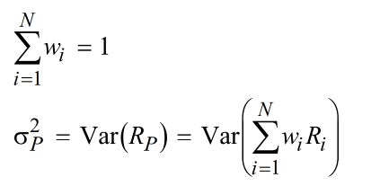

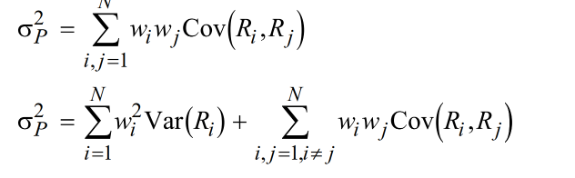



For TASK1: weight of each asset in portfolio.

1. We calculate each assts sharpe ratio, choose the TOP1 assets, and If the new asset’s riskadjusted return benefits the portfolio, then the asset should be included, Finally choose ten assets as the portfolio and calculate the weight of each assets st. Sharpe ratio of the chosen portfolio highest.
2. Randomly choose ten assets as a portfolio, calculate the weight that make the sharpe ratio of the portfolio highset. and output the portfolio with the highset SR.

For TASK2: weight of each portfolio

1. Calculate SR of each portfolio, choose ten portfolios and their weights.
2. Randomly choose ten portfolio and calculate the SR.

**And I think TASK1 makes more sense.**